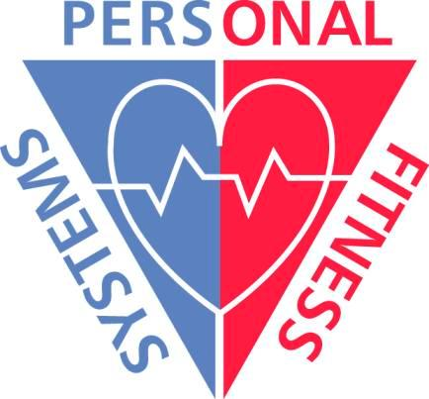
Personal Fitness Systems, Inc.
1545 Larpenteur Avenue
Falcon Heights, MN 55113

Phone: (651) 487-2198
Cell: (651) 492-3477
Fax: (651) 470-7406
keith@pfswellness.com
www.pfswellness.com

- Certified Kinesio Taping Practicioner (CKTP)
- Certified Health and Fitness Specialist with the American College of Sports Medicine (ACSM HFS)
- Licensed Massage Therapist (LMT)
- Licensed Reflexologist (LR)

Patients suffering from injuries related to a motor vehicle accident or injury at work can benefit from my services. I bill the insurance companies directly.

I use various modalities to improve function and/or pain management for your patients living with:

- migraines or headaches
- whiplash
- a repetitive stress injury
- chronic pain
- a decreased amount of cardiovascular endurance
- chronic disease
- biomechanical deficiences
- acute or chronic sports/athletic injuries
- acute or chronic work related injuries

Please review the back for a partial list of conditions addressed with all three or a combination of services.

Phone: (651) 487-2198
Cell: (651) 492-3477
Fax: (651) 470-7406
E-mail: keith@pfswellness.com
Website: www.pfswellness.com

All three  address | Fitness Training only | Kinesio Taping with massage | Kinesio Taping with massage
acute & chronic pain | increase stroke volume and VO2 max | scar management | lymphedema
carpal tunnel | muscular endurance | mortons Neuroma | metatarsal arch
migraine/headache | improve muscle strength ratios | si joint | osgood-schlatter
spinal cord injury | improve insulin sensitivity | patellar tendonitis | depression
whiplash | type II diabetes | thoracic outlet | bursitis
systemic circulation | post-cardiac rehab | TMJ | ligament correction
kinesthetic awareness | reduce risk of cancer of colon and breast | trochanteric bursitis | tendon correction
tendonitis | cardiovascular endurance | fascial correction | shinsplints
ligament sprain | muscular strength | shoulder impingement | space correction
muscle strain | body composition | muscle spasm | lymphatic drainage
iliotibial band | triglyceride reduction | torticollis | hip pointer
fibromyalgia | HDL:LDL ratio | cervical strain | scoliosis
scoliosis | immunocompetency | cervical sprain | shin splints
sciatica | bone mineral density | dequervains | turf toe
fasciitis | CAD reduction | frozen shoulder | morton’s neuroma
osteoarthritis | osteoporotic fracture reduction | dislocations | AC joint
rotator cuff | gallbladder disease | brachial plexus | cervical spondylitis

